**PROJECT REPORT**

(Project Term feb-march 2022)

## (Debit/Credit card fraud detection using ML)

Submitted by

**(Ravi Pandey ) Registration Number :11910459**

**Project Group Number B**

**Course Code INT247**

Under the Guidance of

(Dr. Sagar Pande)

# **School of Computer Science and Engineering**



**DECLARATION**

We hereby declare that the project work entitled (“ Debit/Credit card fraud detection using ML ”) is an authentic record of our own work carried out as requirements of Project for the award of B.Tech degree in Computer science from Lovely Professional University, Phagwara, under the guidance of (Dr. Sagar Pande), during February-March 2022. All the information furnished in this project report is based on our own intensive work and is genuine.

Project Group Number: B

Name of Student : Ravi Pandey

Registration Number: 11910459

(Ravi Pandey)

Date: 24-03-2022

**CERTIFICATE**

This is to certify that the declaration statement made by this group of students is correct to the best of my knowledge and belief. They have completed this Project under my guidance and supervision. The present work is the result of their original investigation, effort and study. No part of the work has ever been submitted for any other degree at any University. The Project is fit for the submission and partial fulfillment of the conditions for the award of B.Tech degree in Computer Science from Lovely Professional University, Phagwara.

**Signature and Name of the Mentor**

**Designation**

**School of Computer Science and Engineering,**

Lovely Professional University,

Phagwara, Punjab.

Date :20-03-2022

**ACKNOWLEDGEMENT**

I would sincerely like to thanks for the constructive criticism, support, encouragment

valuable, comments, suggestions, timely helps and many innovative ideas given to

me by my project supervisor Dr sagar Pande in carrying out project and the report

I must convey my gratitude to Dr sagar Pande for giving me the constant source of

Inspiration and help in preparing the project ,personally correcting me Providing

encouragement throughout the project.

I also thanks all my faculty members for steering me through the tough as well as

Easy phase of the project in result oriented manner with concern attention.

**INTRODUCTION**

My name is Ravi Pandey. currently, I am pursuing Btech from Lovely professional

university in computer science. Here I am to tell about my project which I have

completed during February-march**.** my project topic is “ Debit/Credit card fraud detection

using ML”. in this project I have write code which when it run its detected Debit/Credit

card

Abstract

Credit card fraud detection present several characteristics that makes it a challenging task. First,

the feature set describing a credit card transaction usually ignores detailed sequential information

which was proven to be very relevant for the detection of credit card fraudulent transactions.

Second, purchase behaviours and fraudster strategies may change over time, making a learnt

fraud detection decision function irrelevant if not updated. This phenomenon named dataset shift

(change in the distribution p(x, y)) may hinder fraud detection systems to obtain good

performances. We conducted an exploratory analysis in order to quantify the day by day dataset

shift and identified calendar related time periods that show different properties. Third, credit card

transactions data suffer from a strong imbalance regarding the class labels which needs to be

considered either from the classifier perspective or from the data perspective (less than 1% of the

transactions are fraudulent transactions). Solutions for integrating sequential information in the

feature set exist in the literature. The predominant one consists in creating a set of features

which are descriptive statistics obtained by aggregating the sequences of transactions of the

card-holders (sum of amount, count of transactions, etc..). We used this method as a benchmark

feature engineering method for credit card fraud detection. However, this feature engineering

strategies raised several research questions. First of all, we assumed that these descriptive

statistics cannot fully describe the sequential properties of fraud and genuine patterns and that

modelling the sequences of transactions could be beneficial for fraud detection. Moreover the

creation of these aggregated features is guided by expert knowledge whereas sequences

modelling could be automated thanks to the class labels available for past transactions. Finally,

the aggregated features are point estimates that may be completed by a multi-perspective

univariate description of the transaction context (especially from the point of view of the seller).

We proposed a multi-perspective HMM-based automated feature engineering strategy in order

to incorporate a broad spectrum of sequential information in the transactions feature sets. In fact,

we model the genuine and fraudulent behaviours of the merchants and the card-holders

according to two univariate features: the timing and the amount of the transactions. Moreover,

the HMMbased features are created in a supervised way and therefore lower the need of expert

knowledge for the creation of the fraud detection system. In the end, our multiple perspectives

HMM-based approach offers automated feature engineering to model temporal correlations so

as to complement and possibly supplement the use of transaction aggregation strategies in order

to improve the effectiveness of the classification task. Experiments conducted on a large real

world credit card transaction dataset (46 million transactions from belgium card-holders between

March and May 2015) have shown that the proposed HMM-based feature engineering allows for

an increase in the detection of fraudulent transactions when combined with the state of the art

expert based feature engineering strategy for credit card fraud detection. To conclude, this work

leads to a better understanding of what can be considered contextual knowledge for a credit card

fraud detection task and how to include it in the classification task in order to get an increase in

fraud detection. The method proposed can be extended to any supervised task with sequence

List of Screenshote

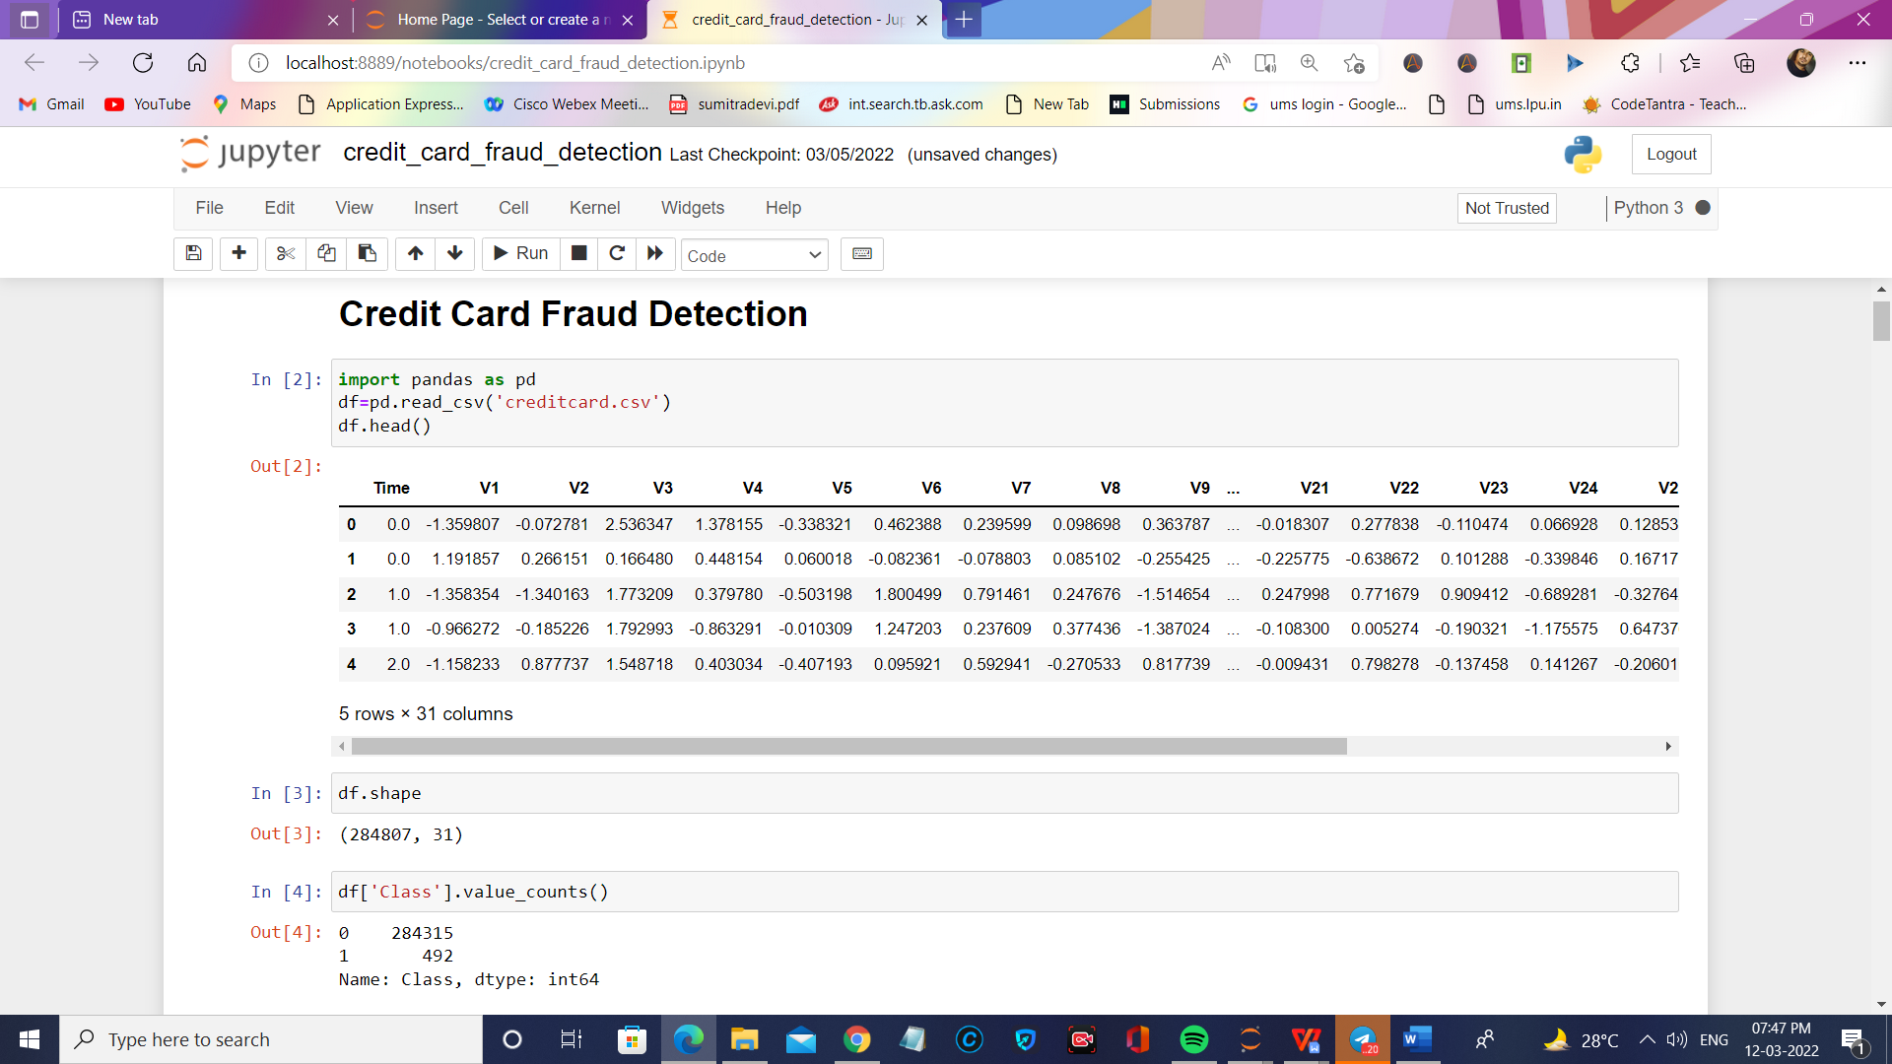

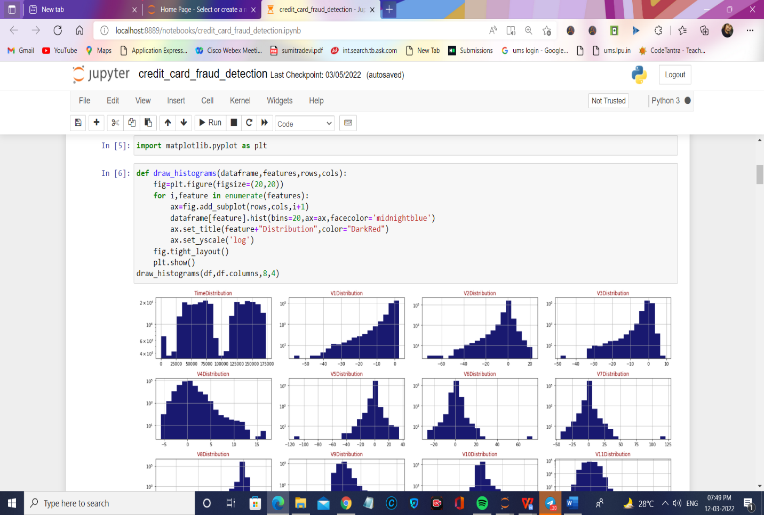

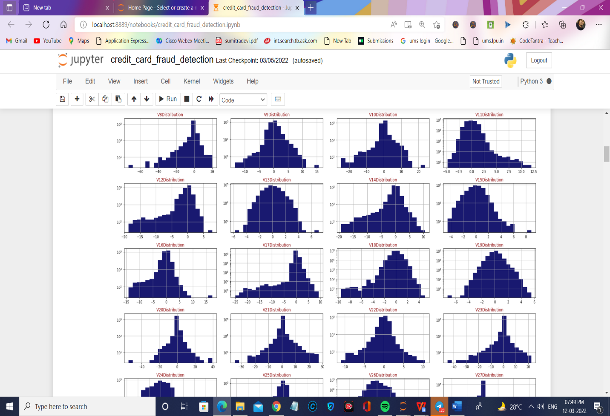

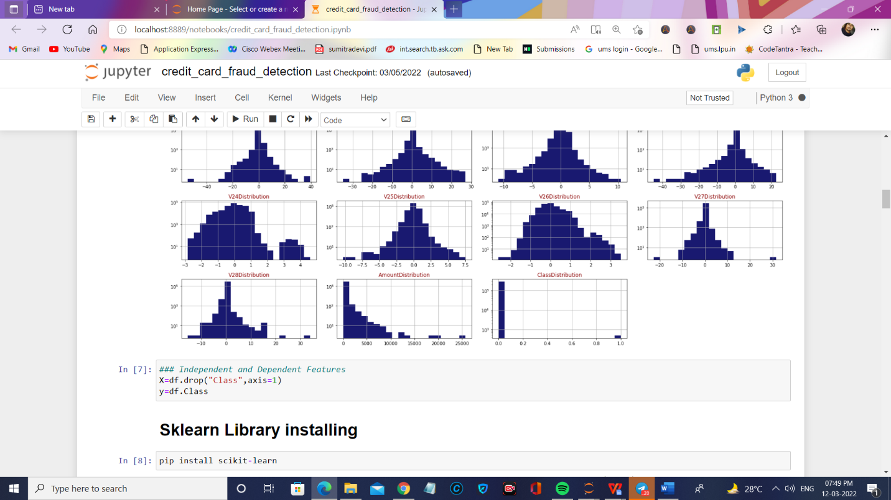

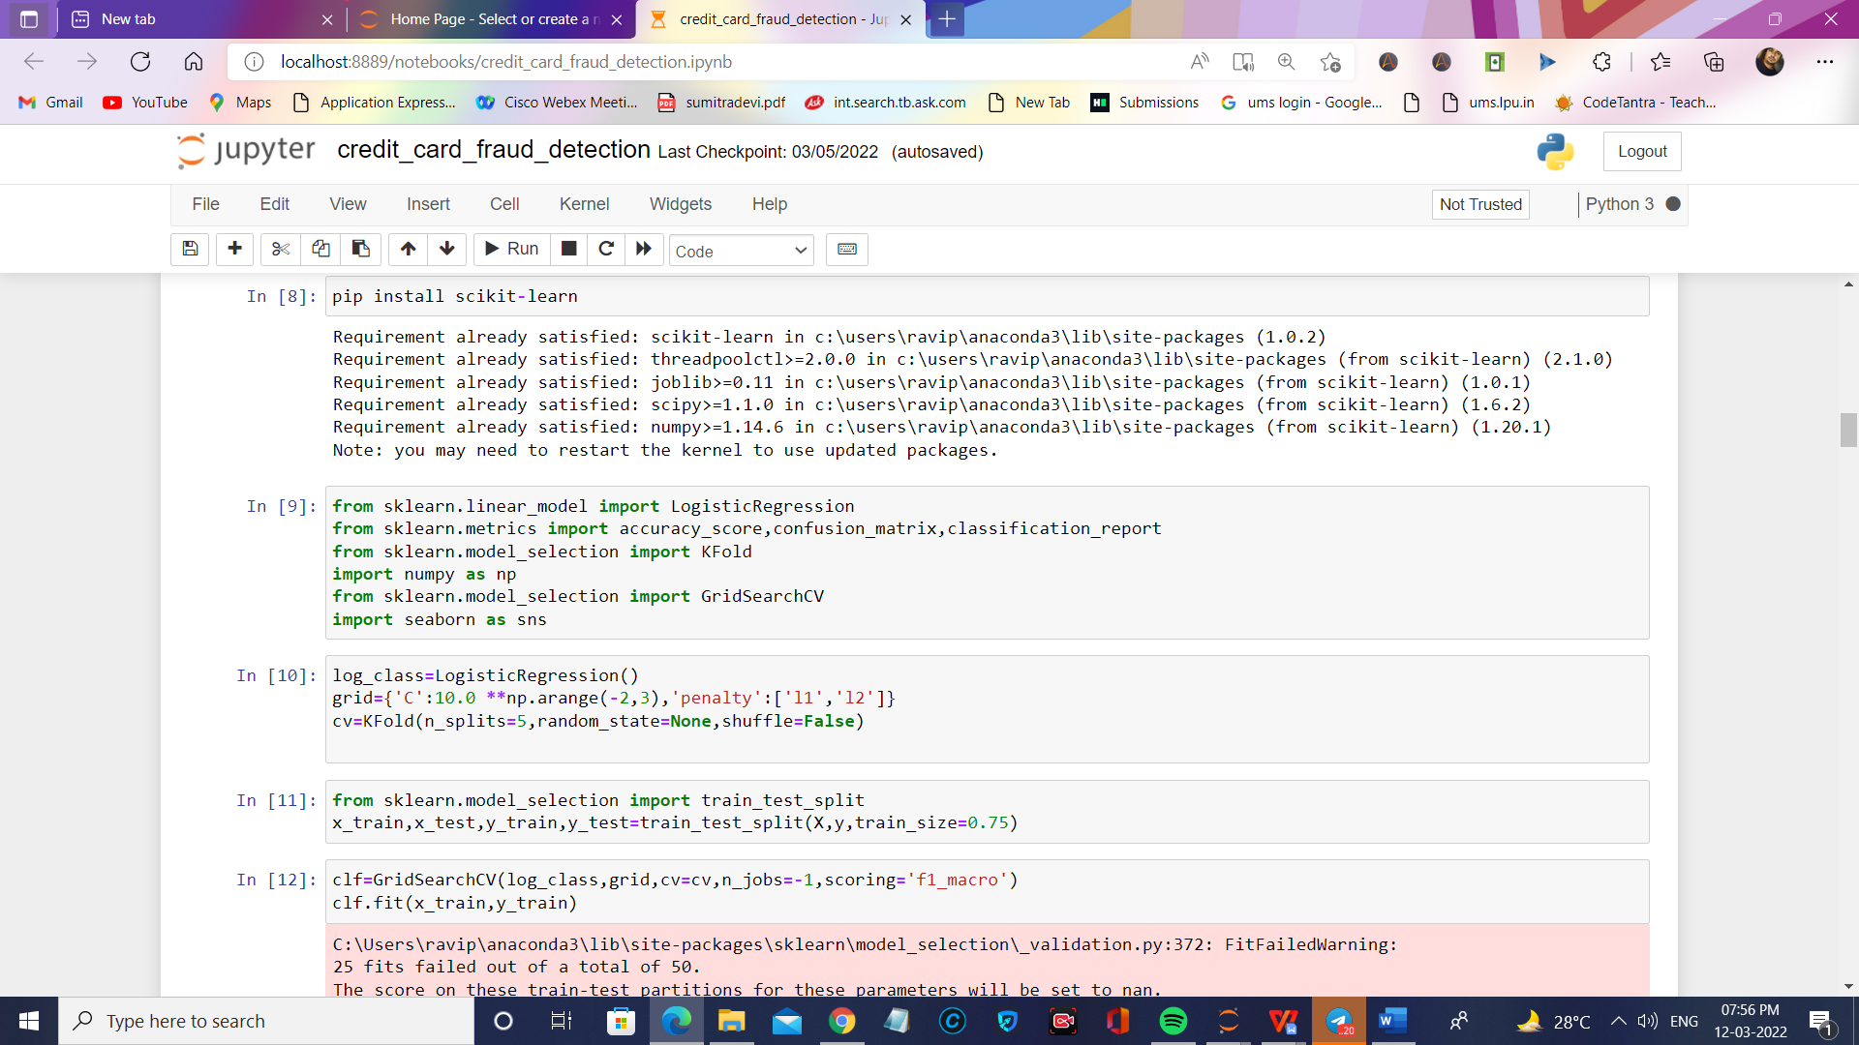

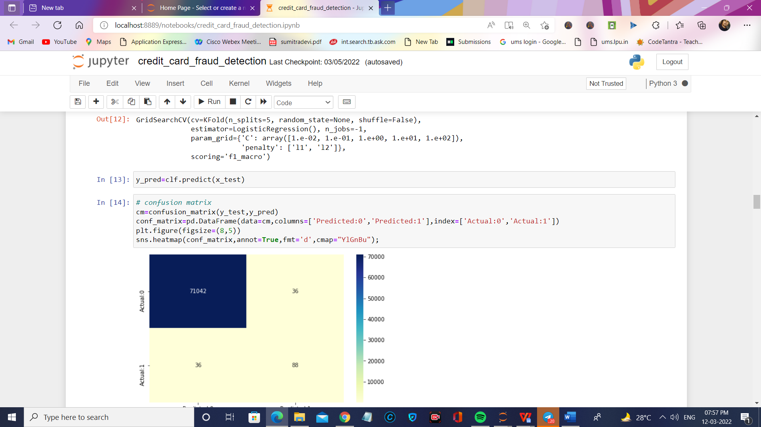

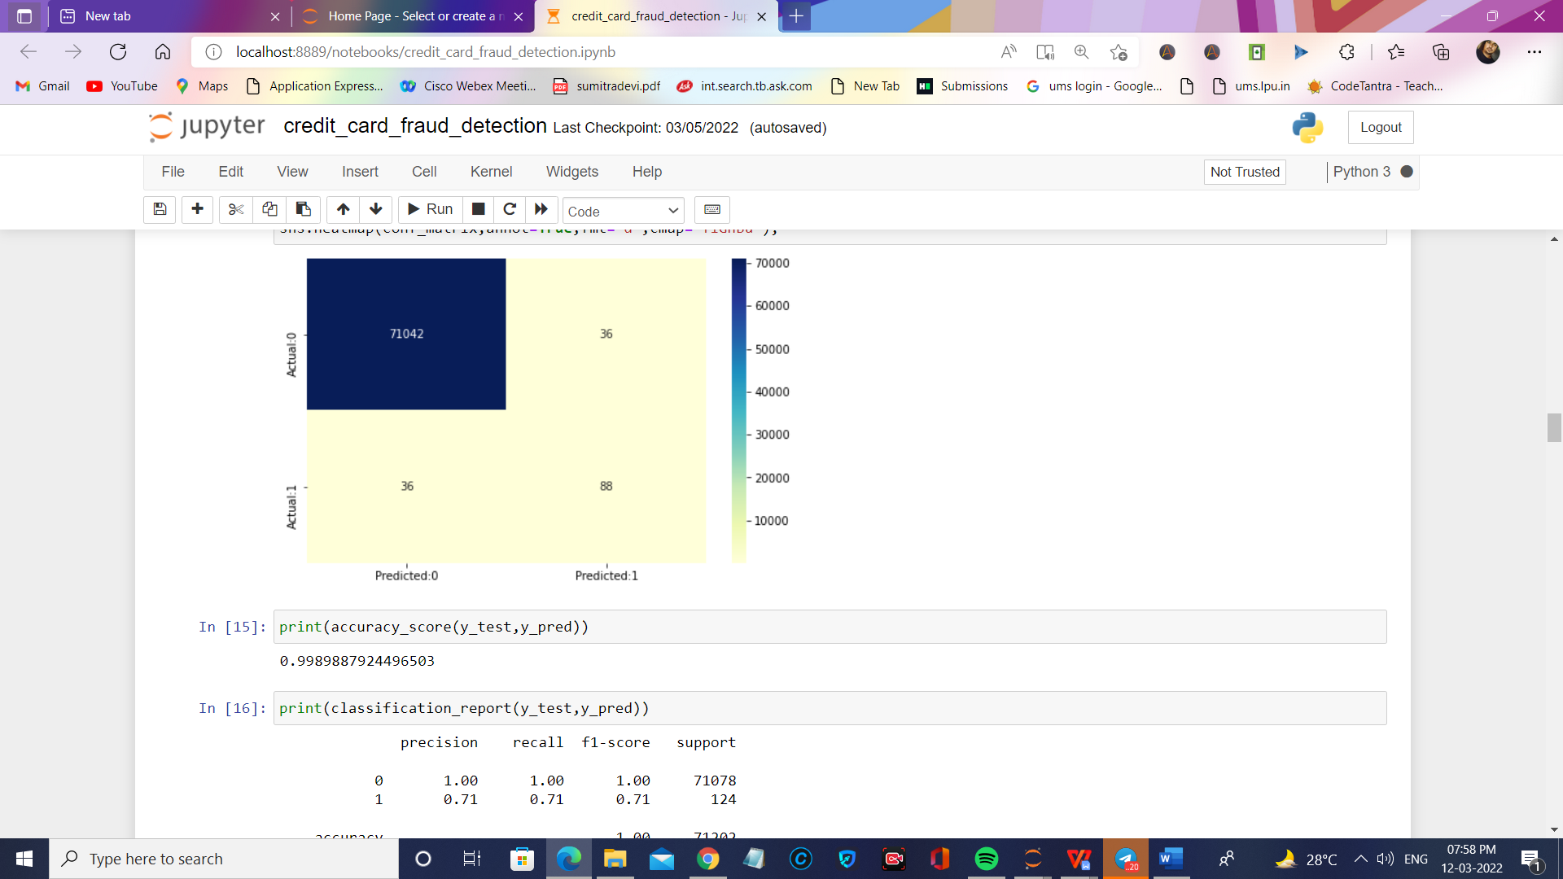

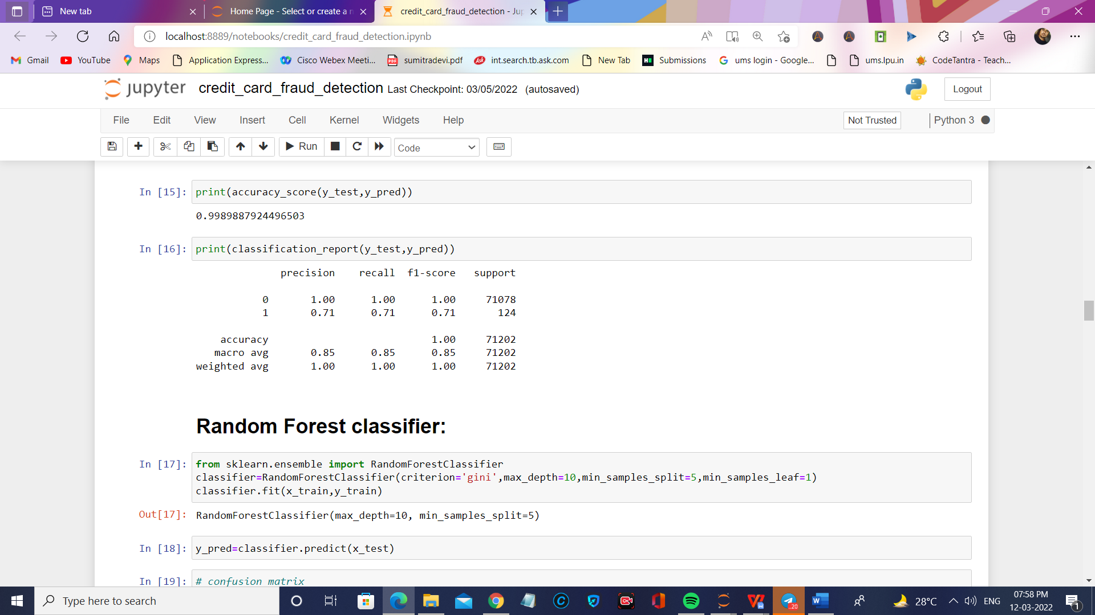

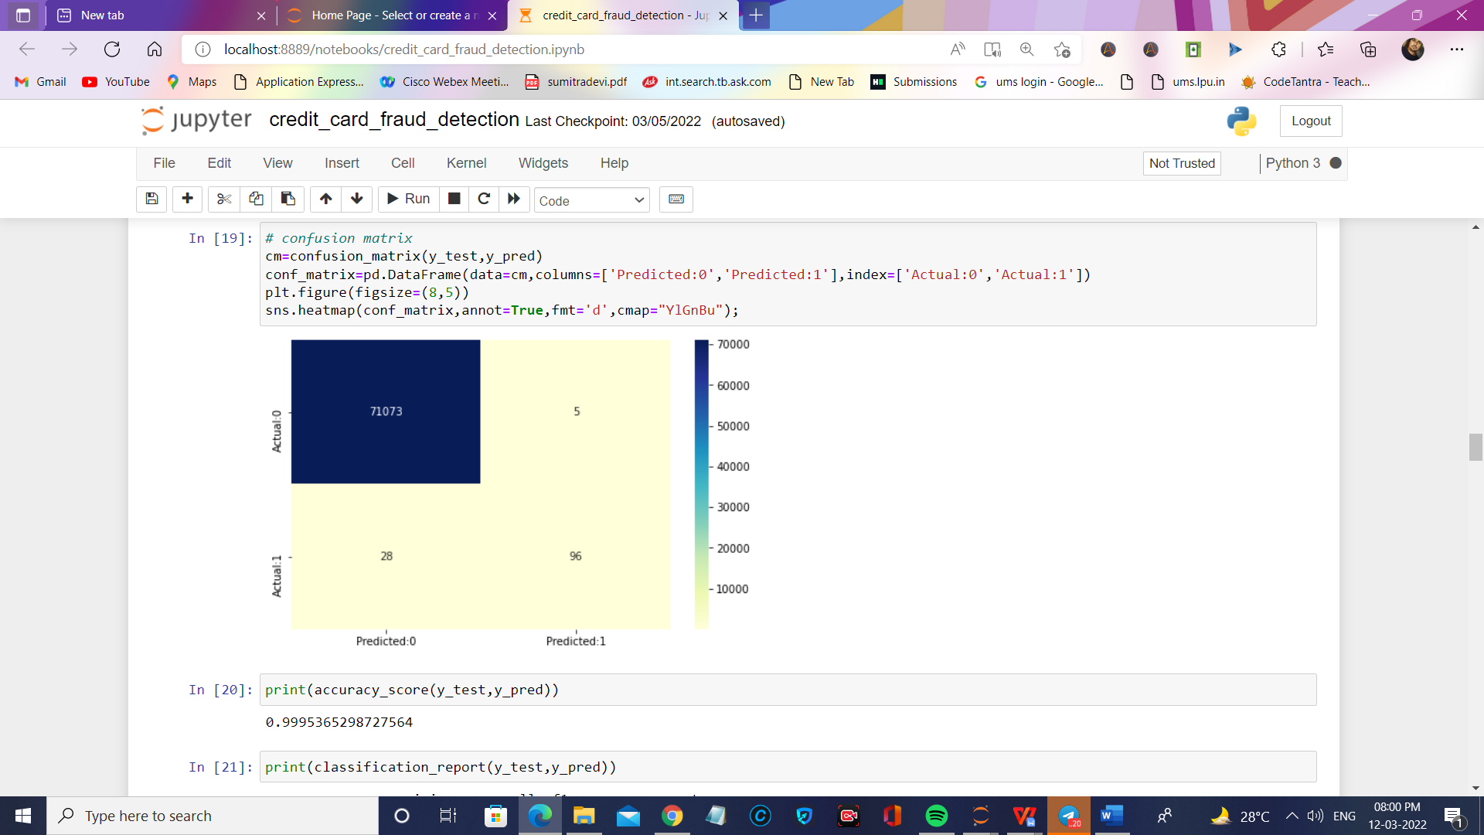

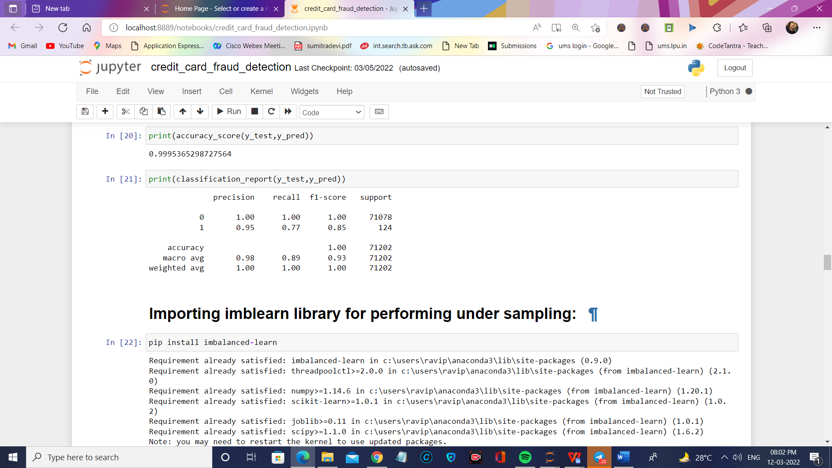

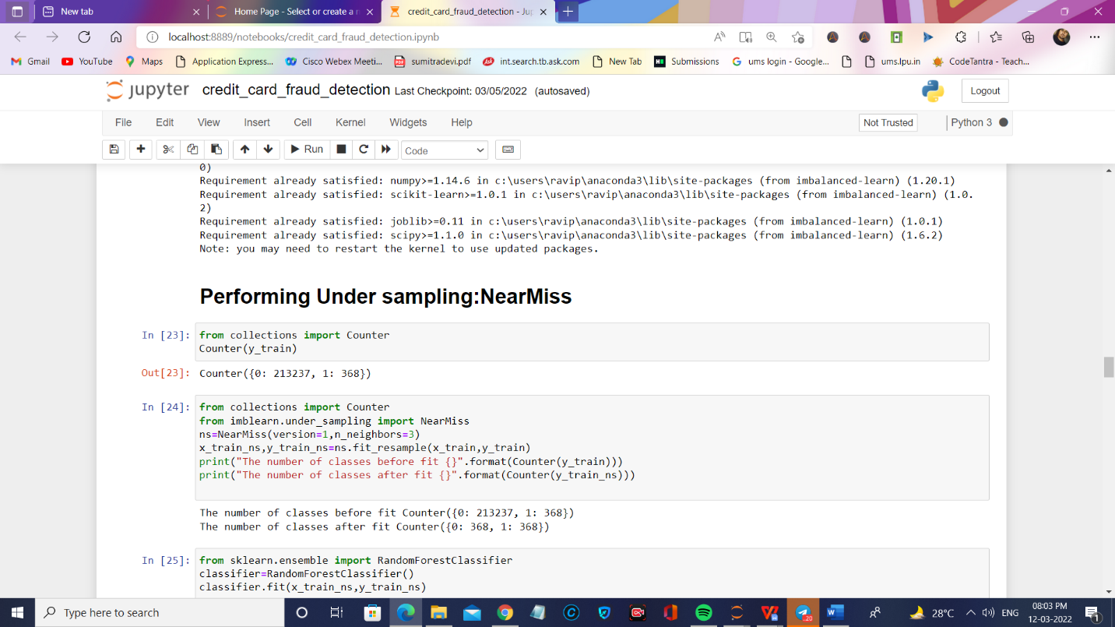

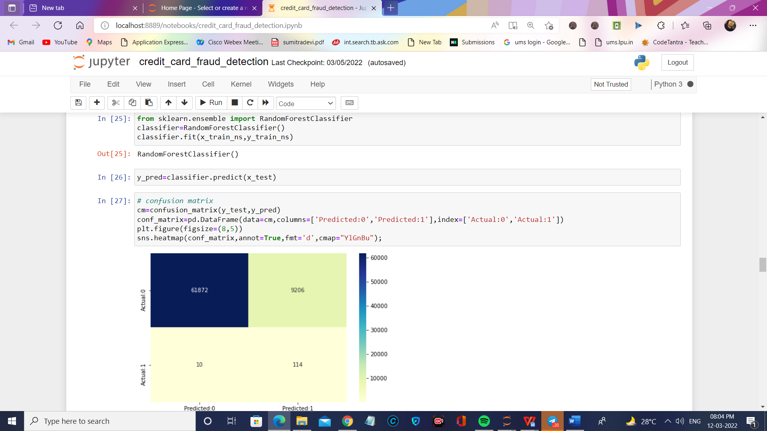

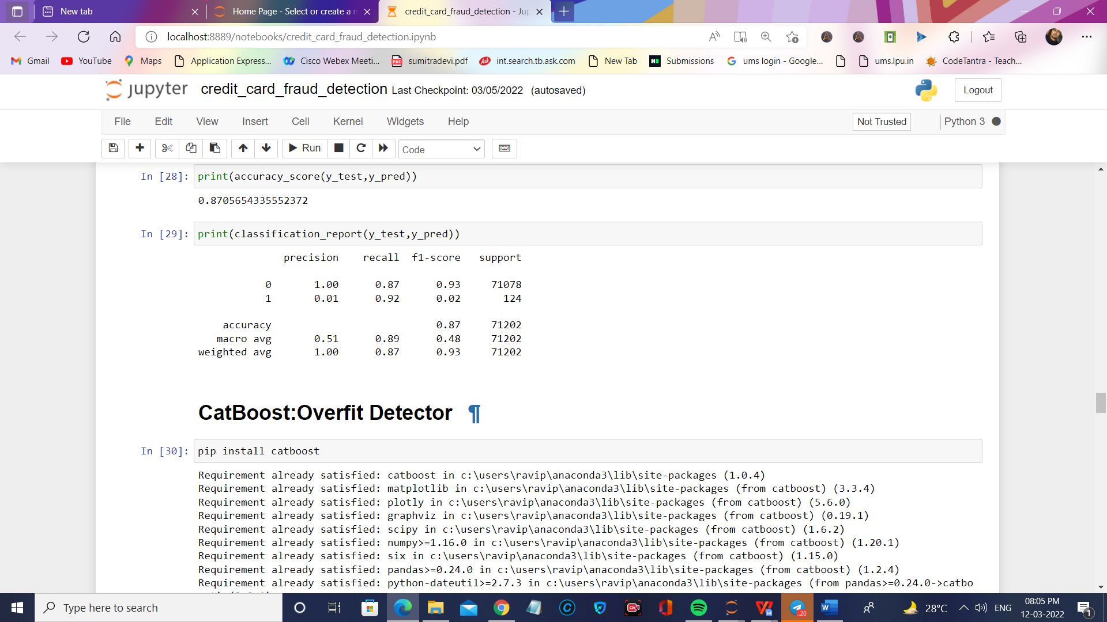

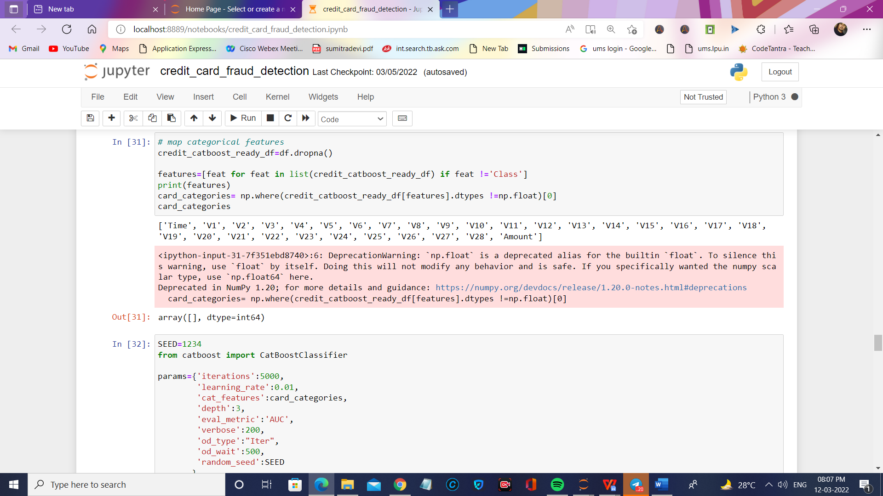

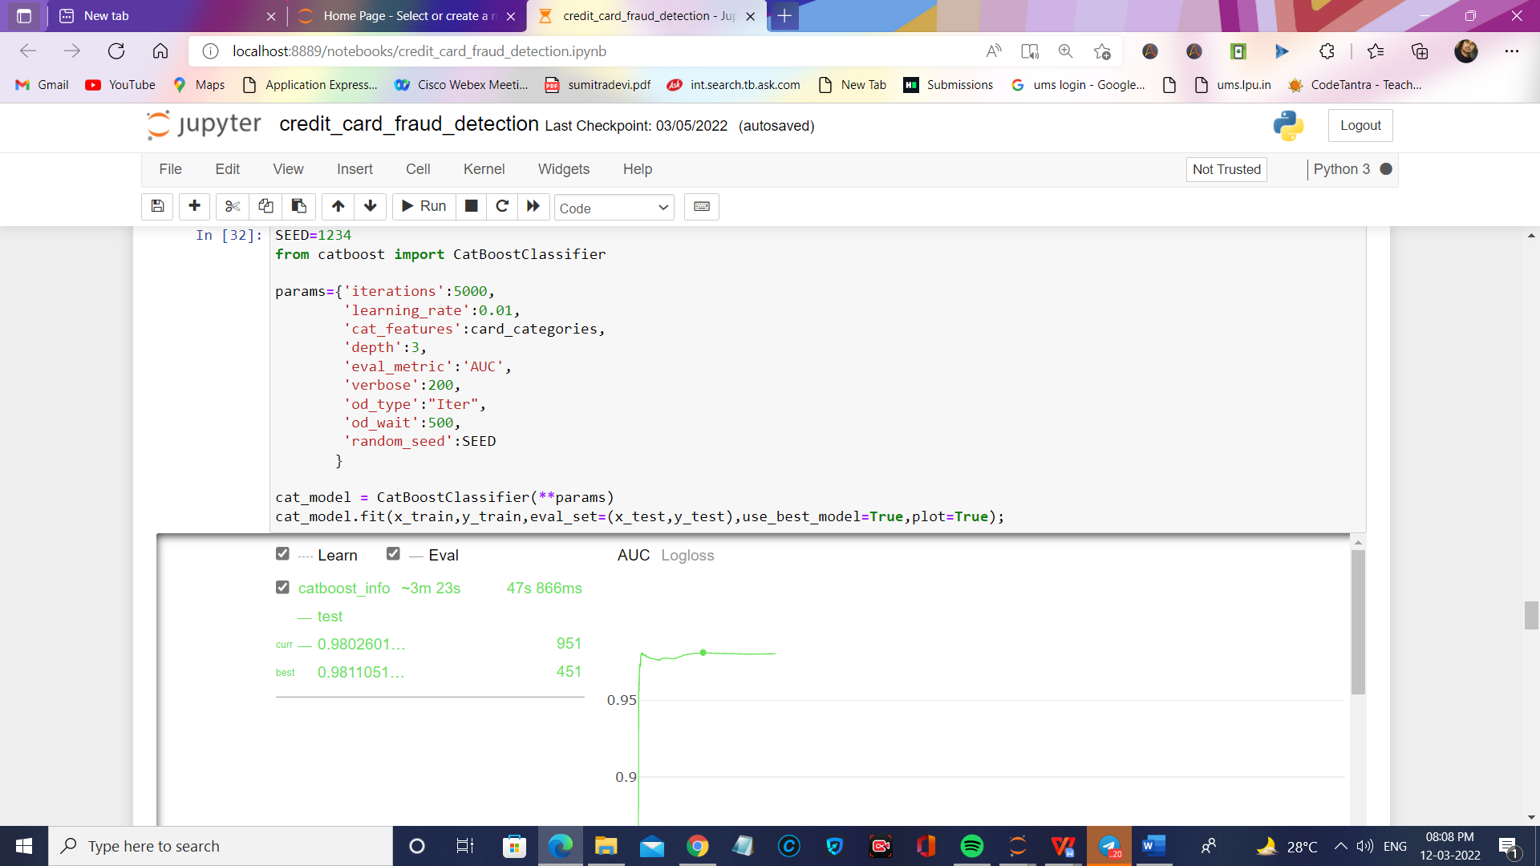

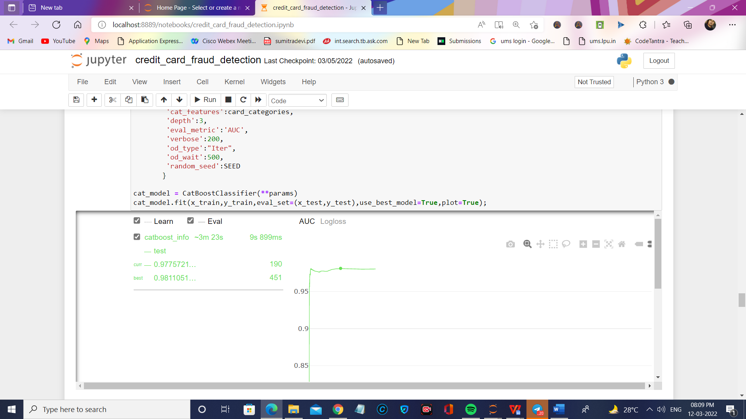

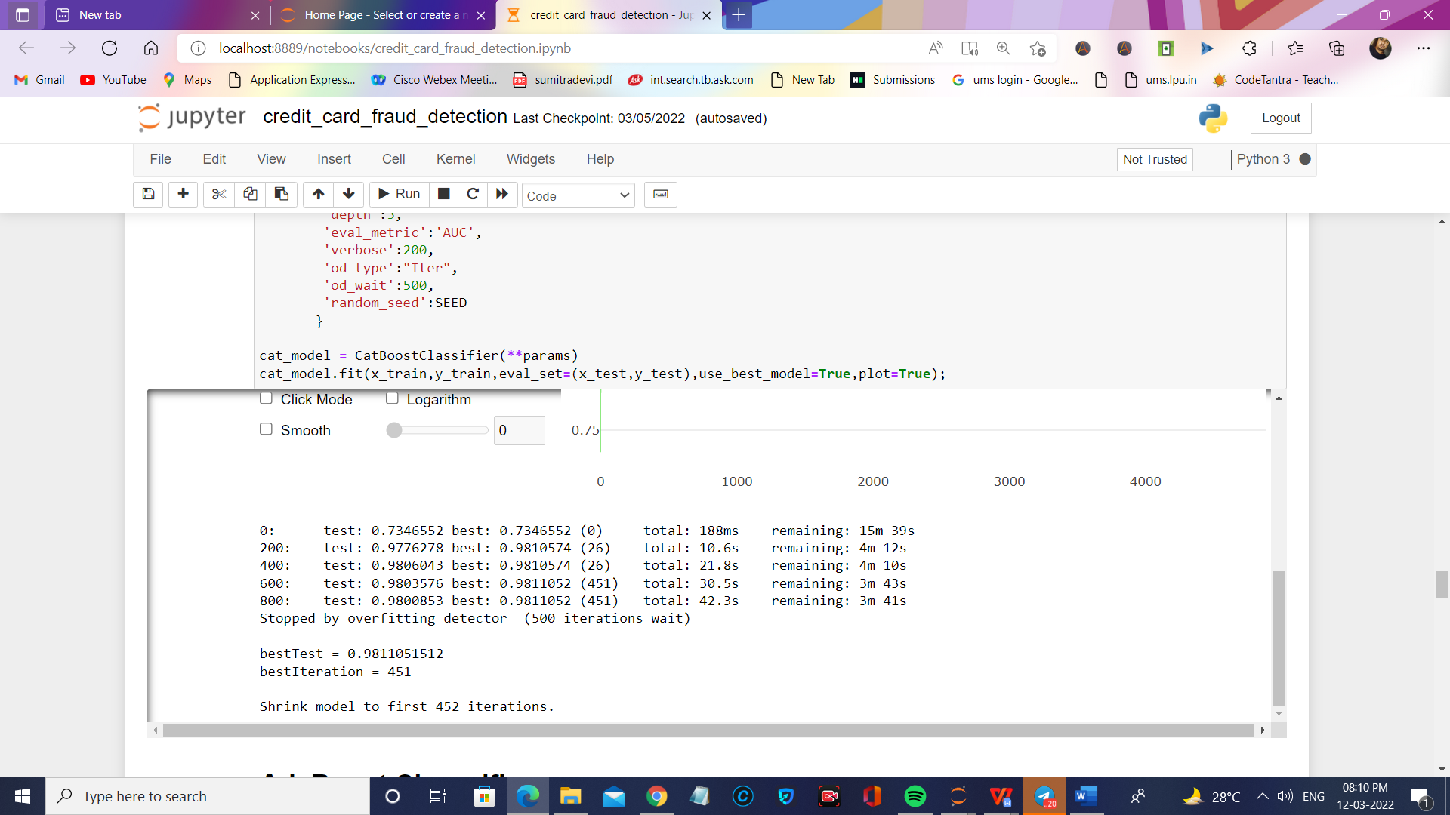

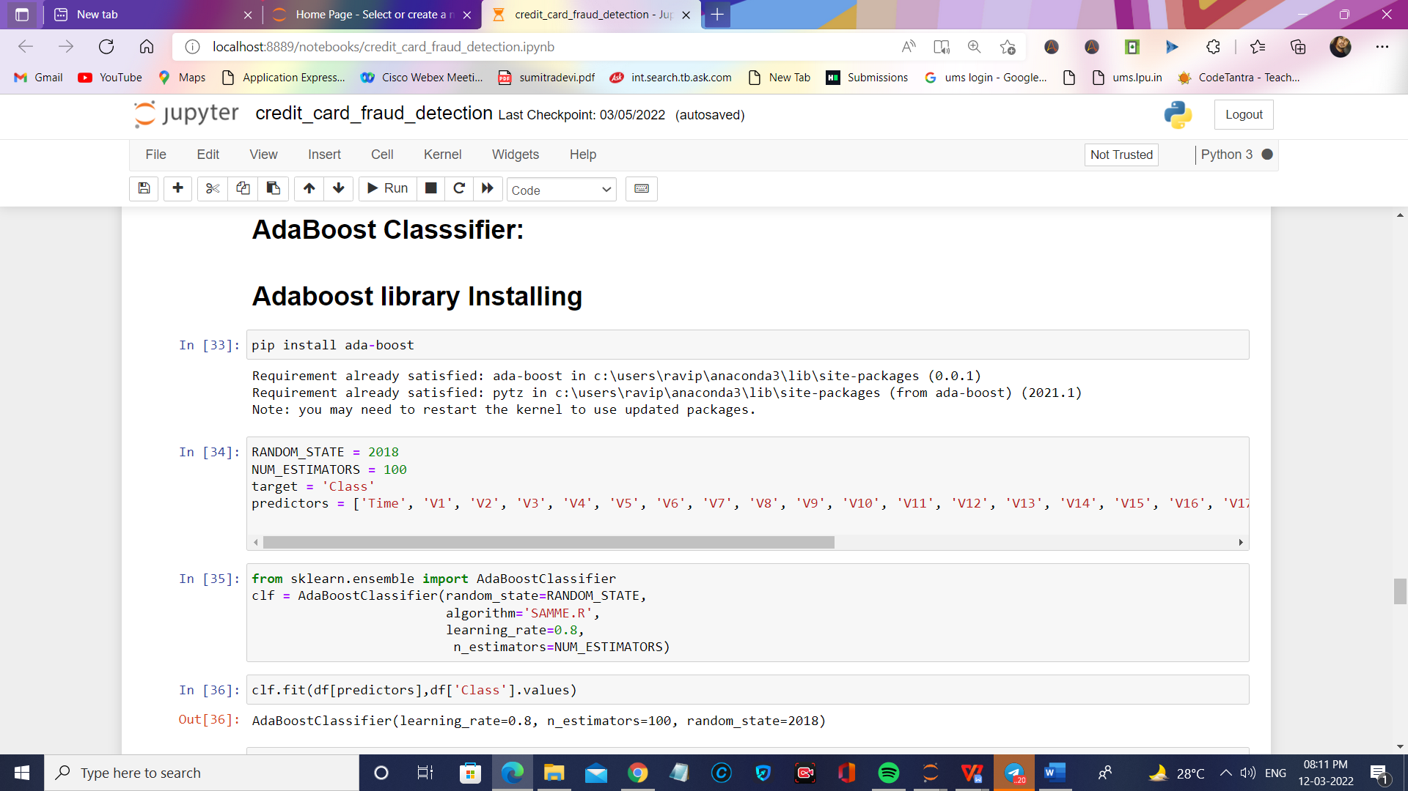

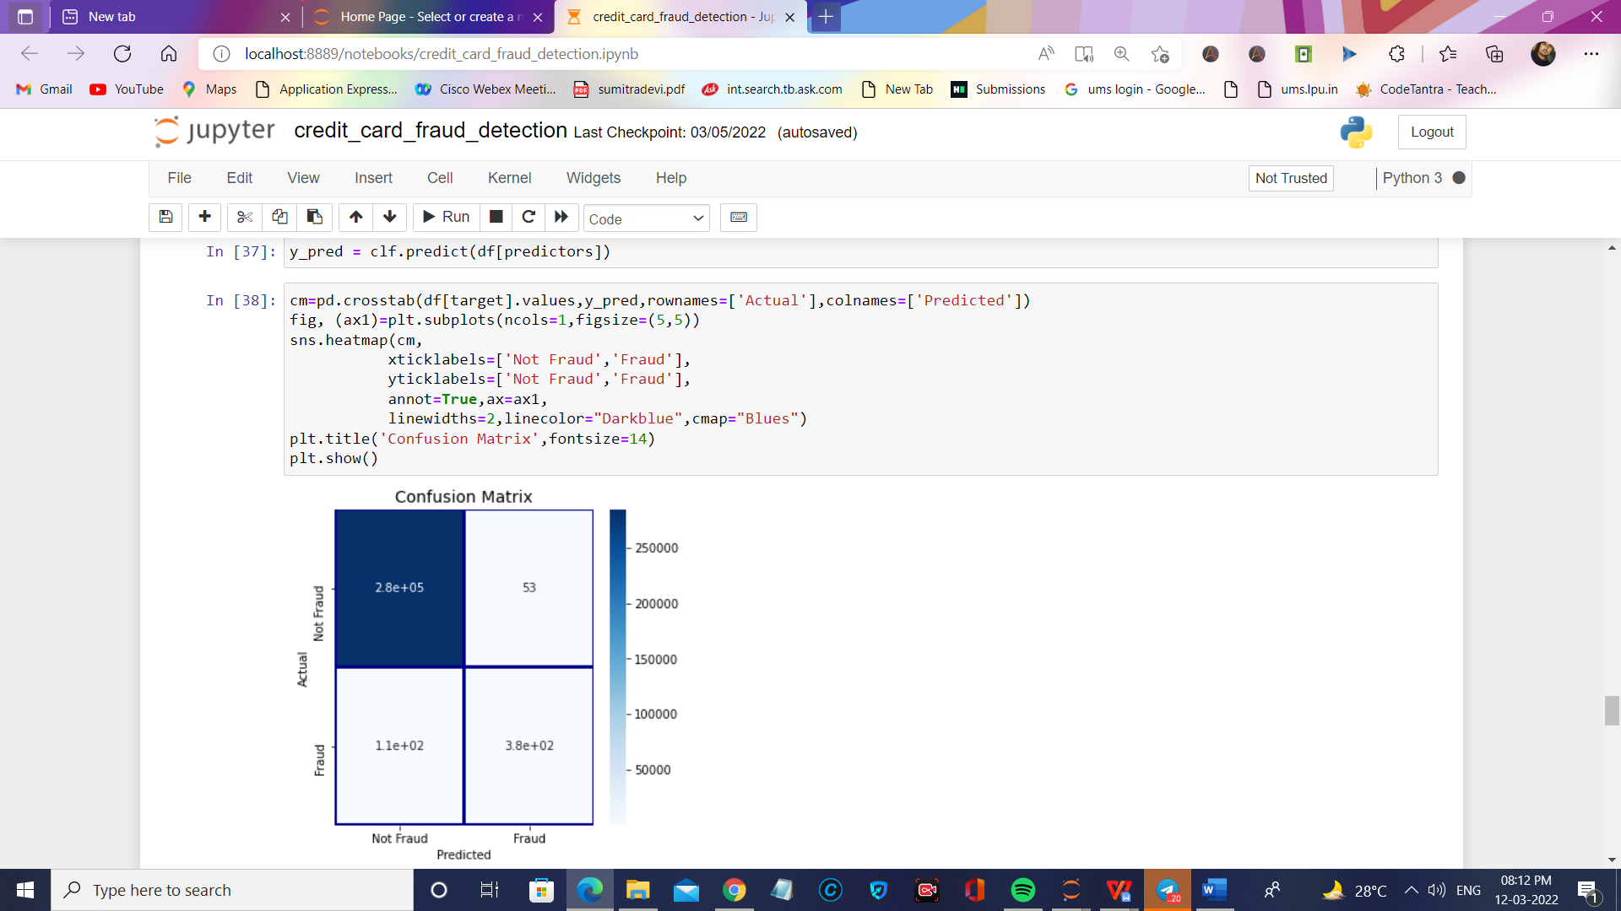

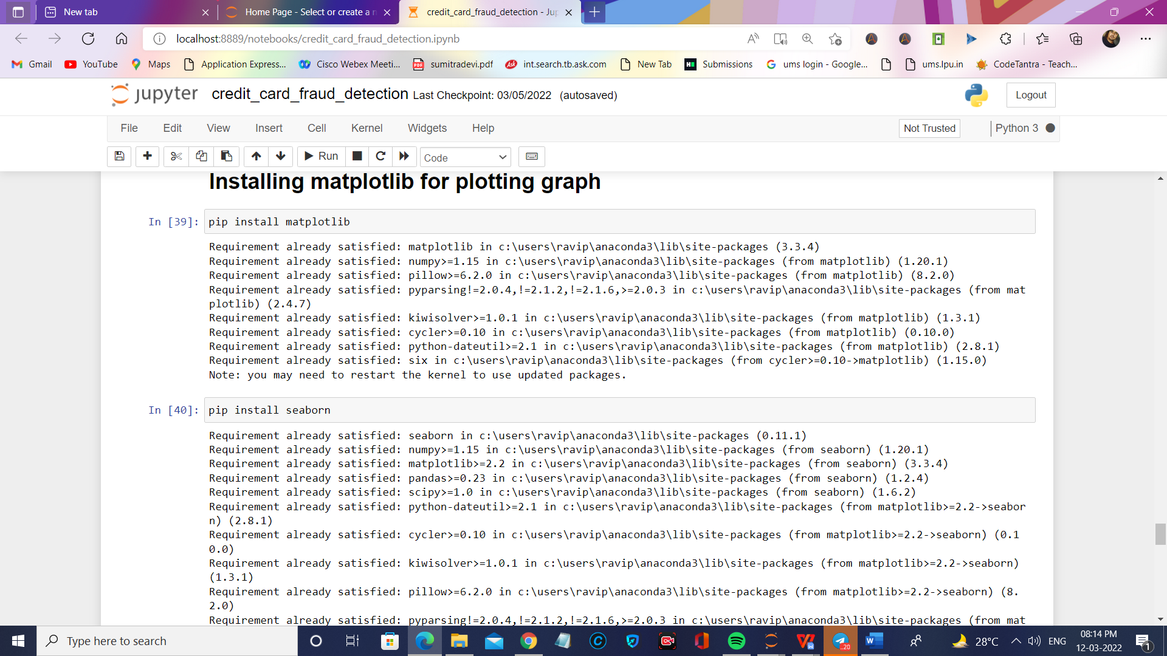

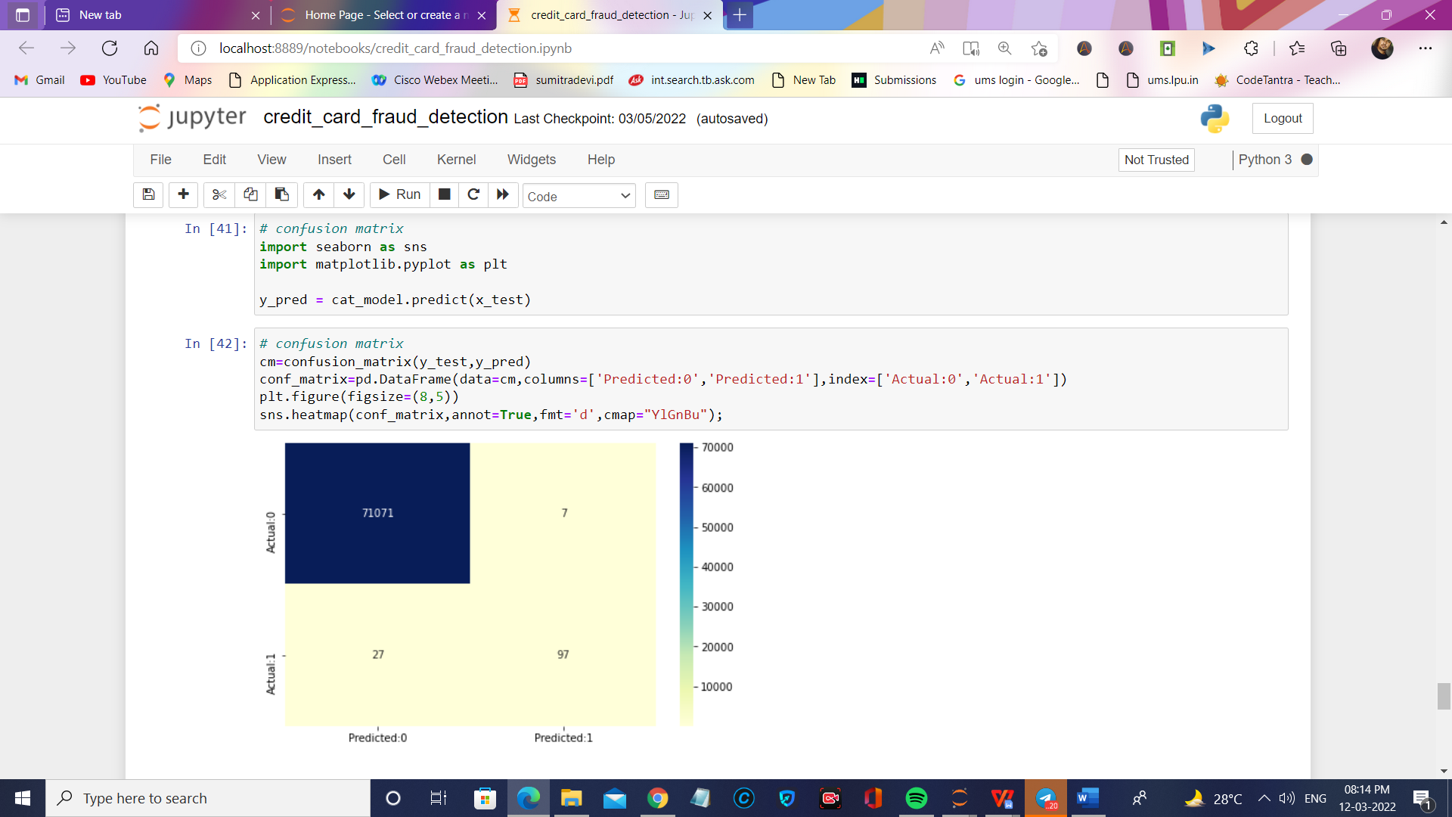

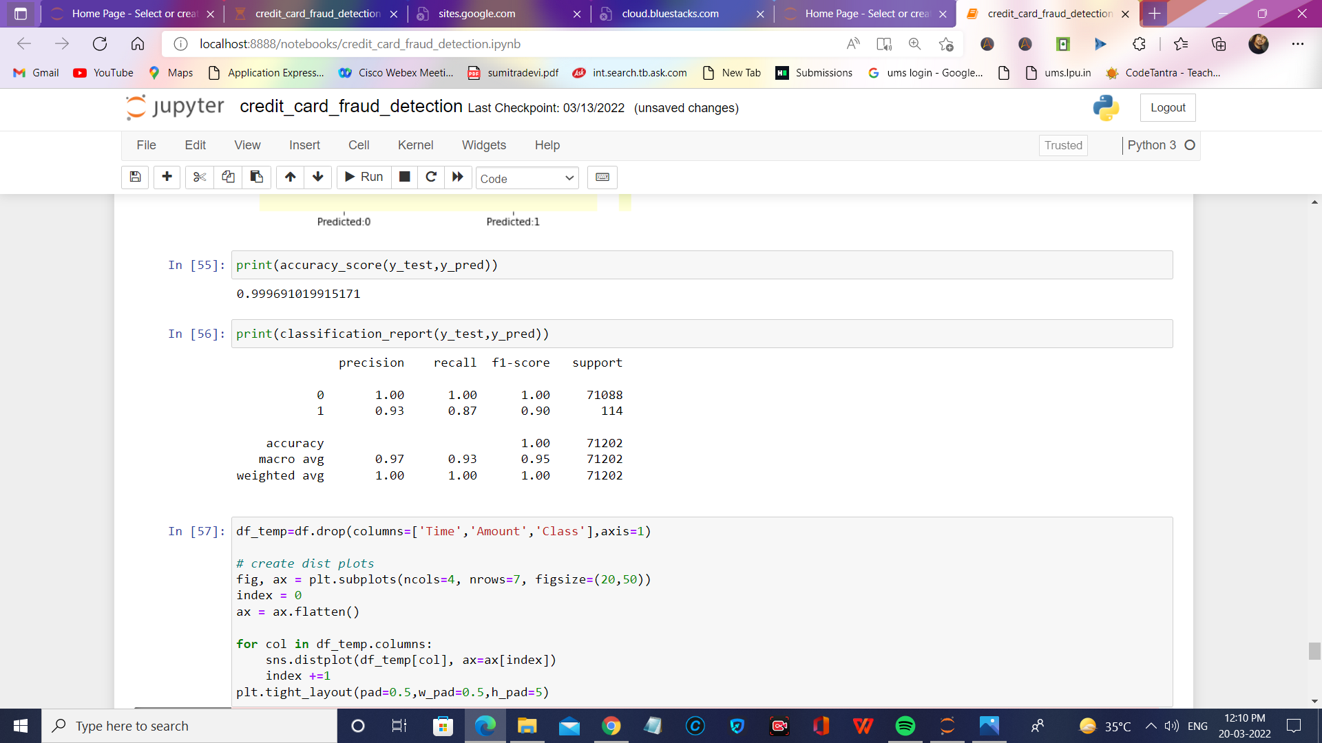

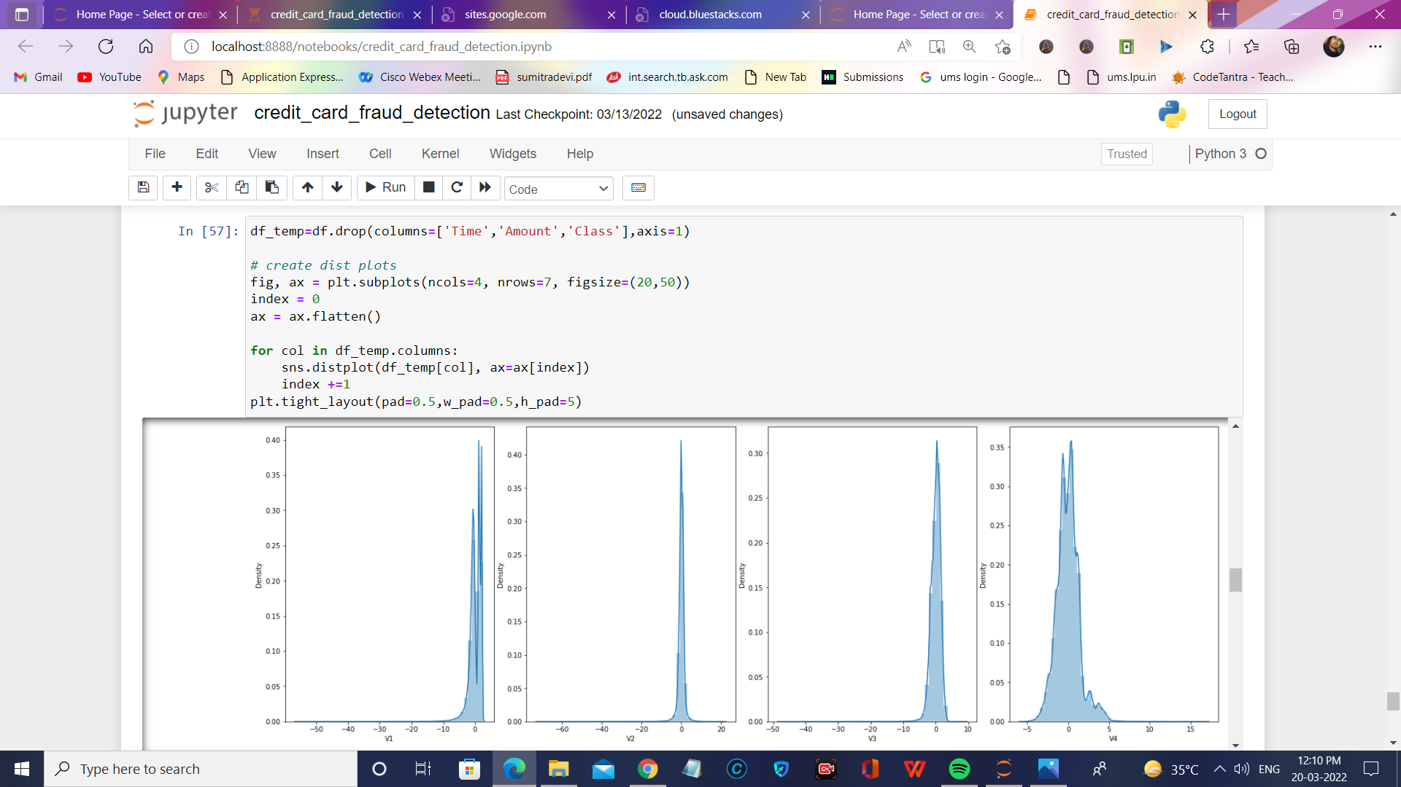

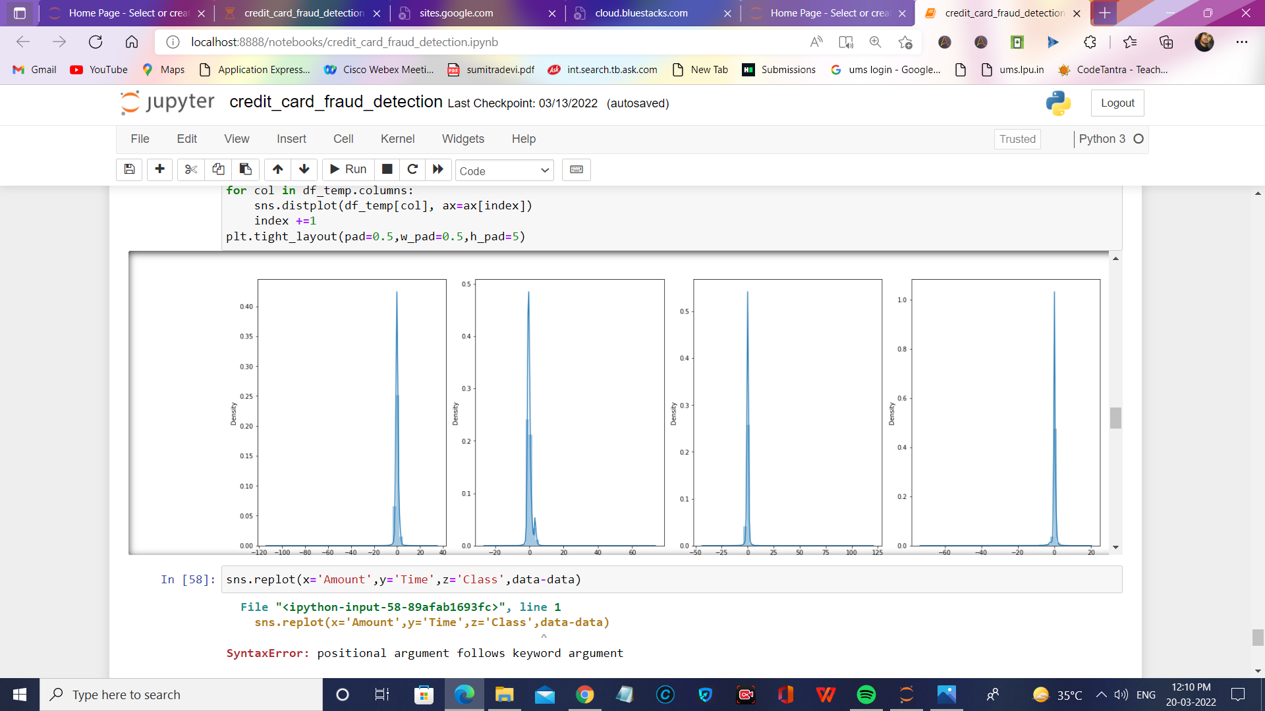

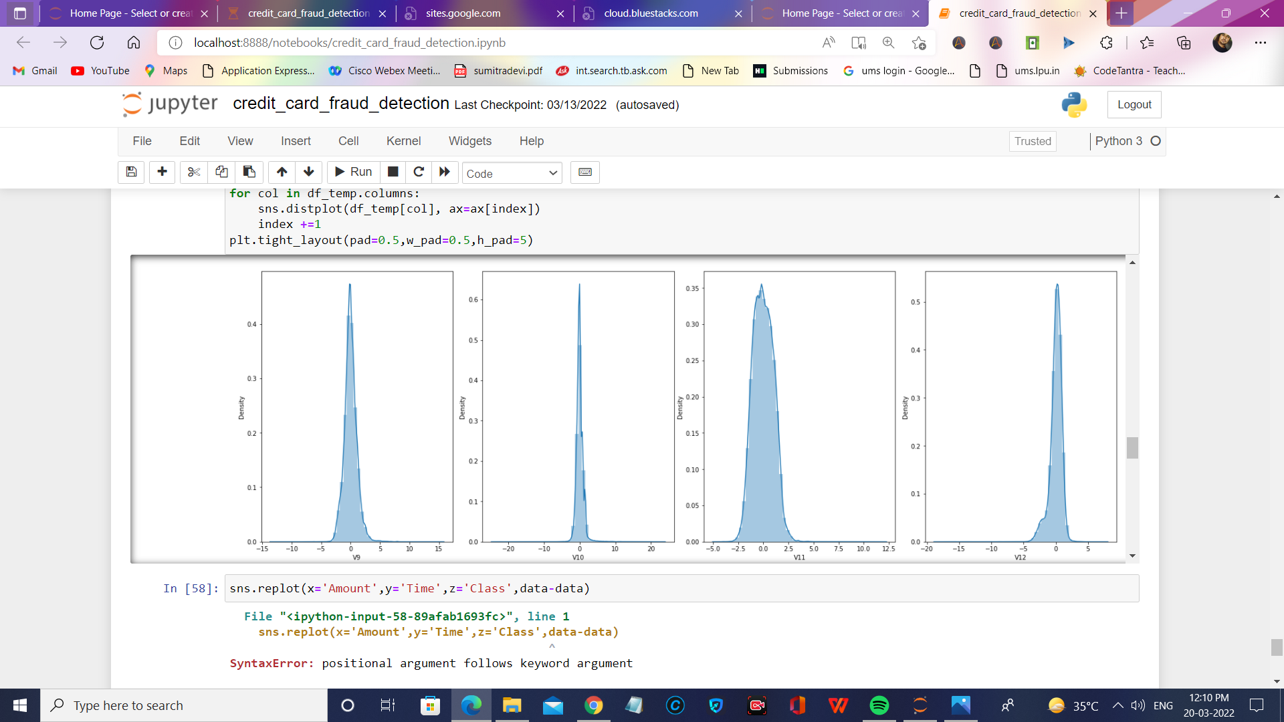

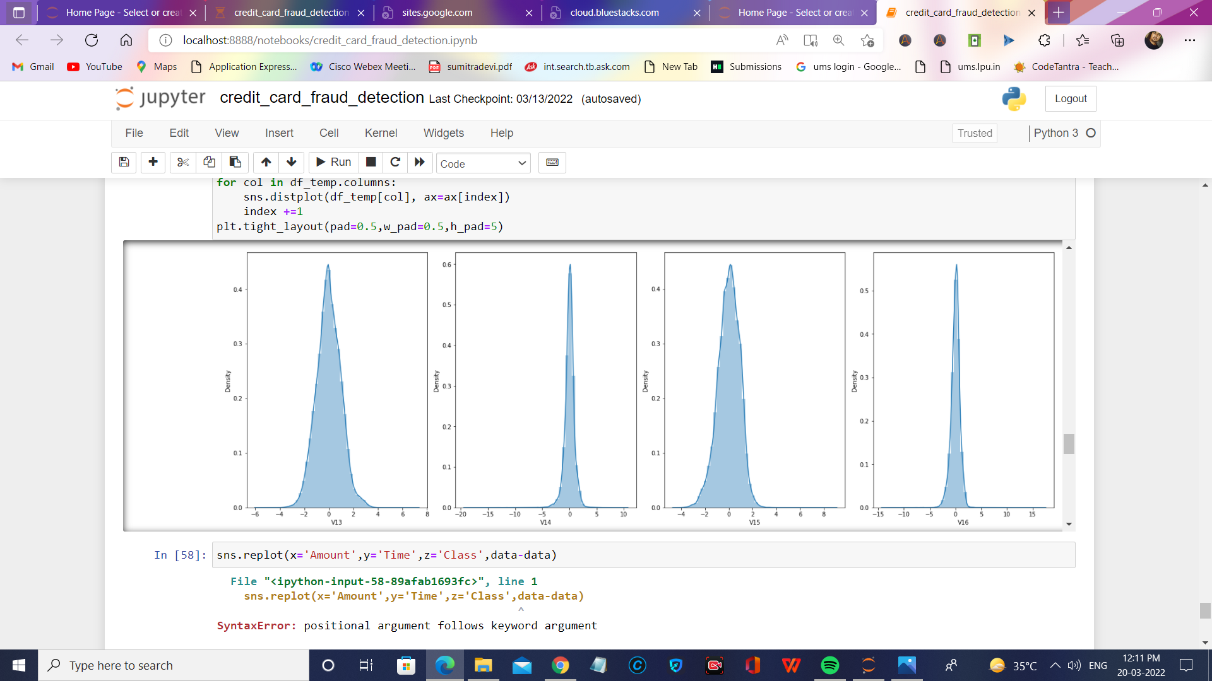

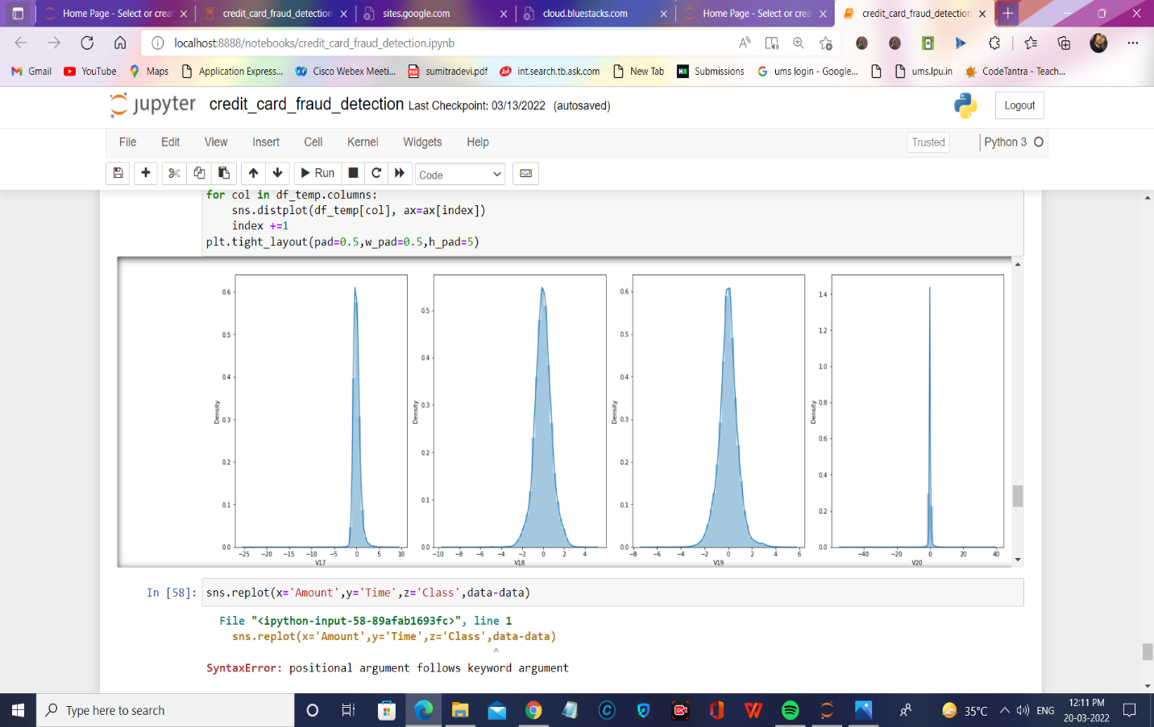

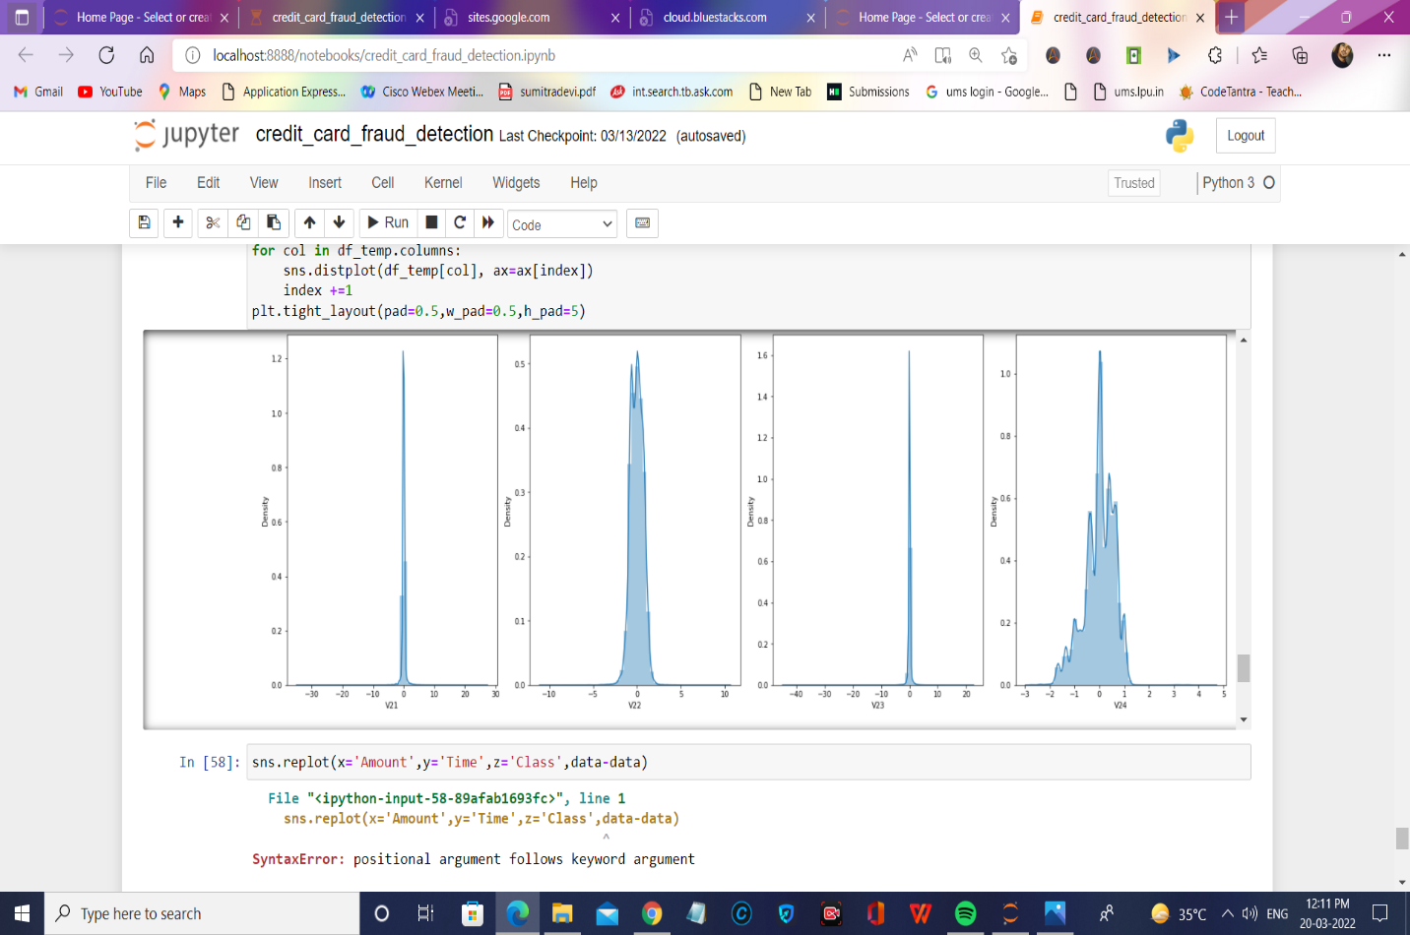

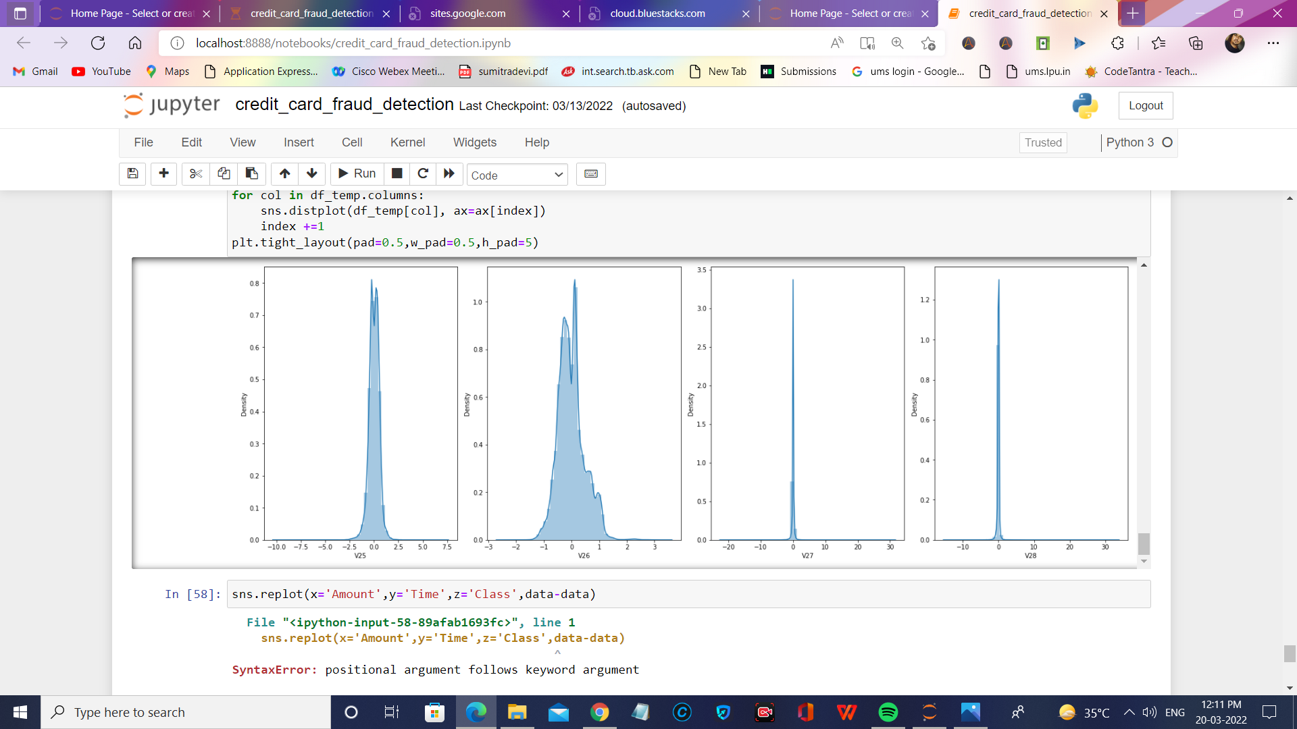

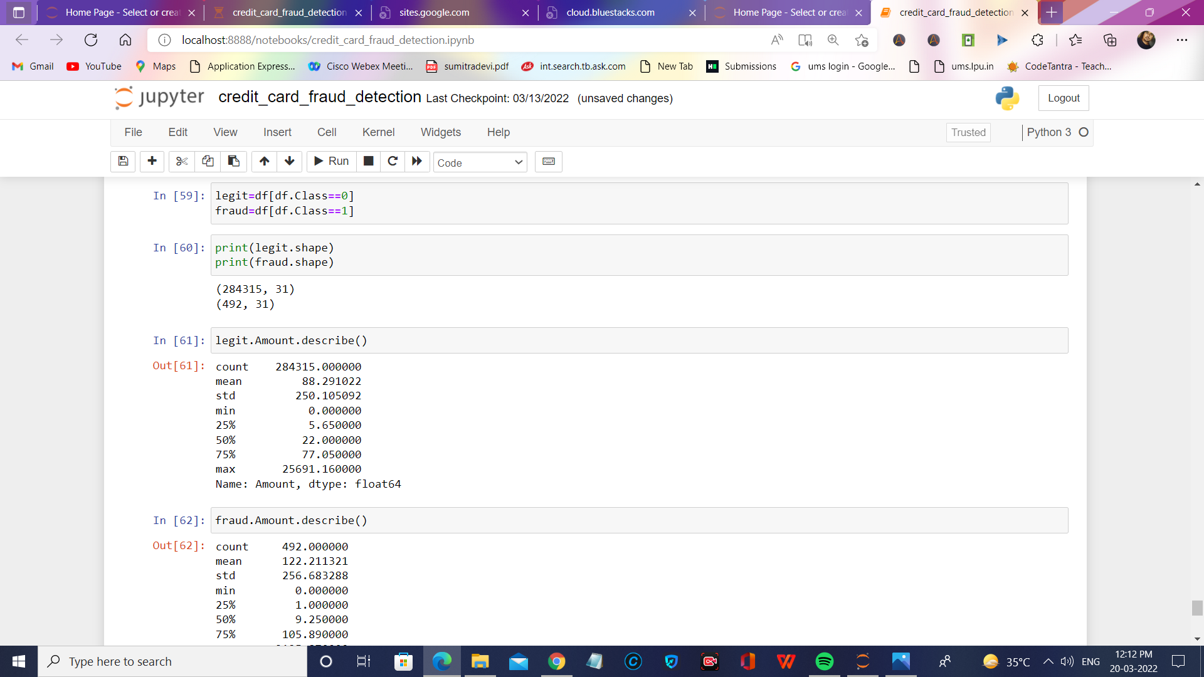

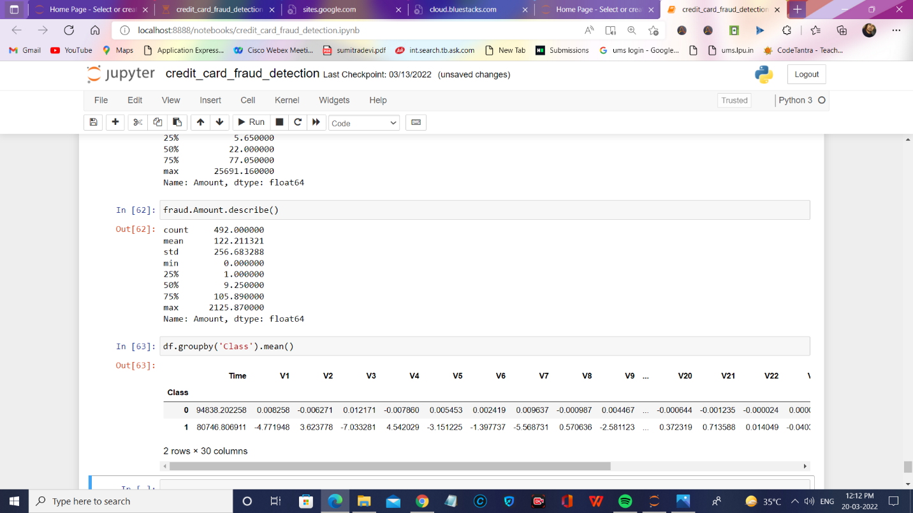

**Pseudo code**

1. import pandas as pd

df=pd.read_csv('creditcard.csv')

df.head()

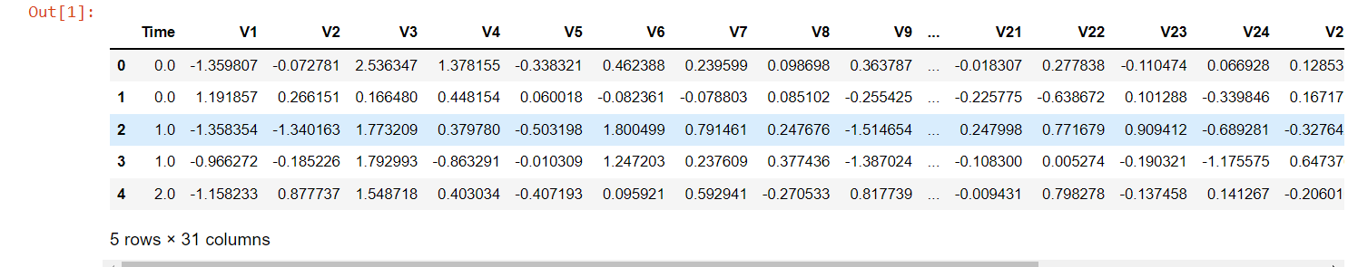

2. df.shape

**output**

(284807, 31)

3. df['Class'].value_counts()

from sklearn.ensemble import RandomForestClassifier

classifier=RandomForestClassifier

**output**

0 284315

1 492

Name: Class, dtype: int64

4. import matplotlib.pyplot as plt

5. def draw_histograms(dataframe,features,rows,cols):

fig=plt.figure(figsize=(20,20))

for i,feature in enumerate(features):

ax=fig.add_subplot(rows,cols,i+1)

dataframe[feature].hist(bins=20,ax=ax,facecolor='midnightblue')

ax.set_title(feature+"Distribution",color="DarkRed")

ax.set_yscale('log')

fig.tight_layout()

plt.show()

draw_histograms(df,df.columns,8,4)

**output**

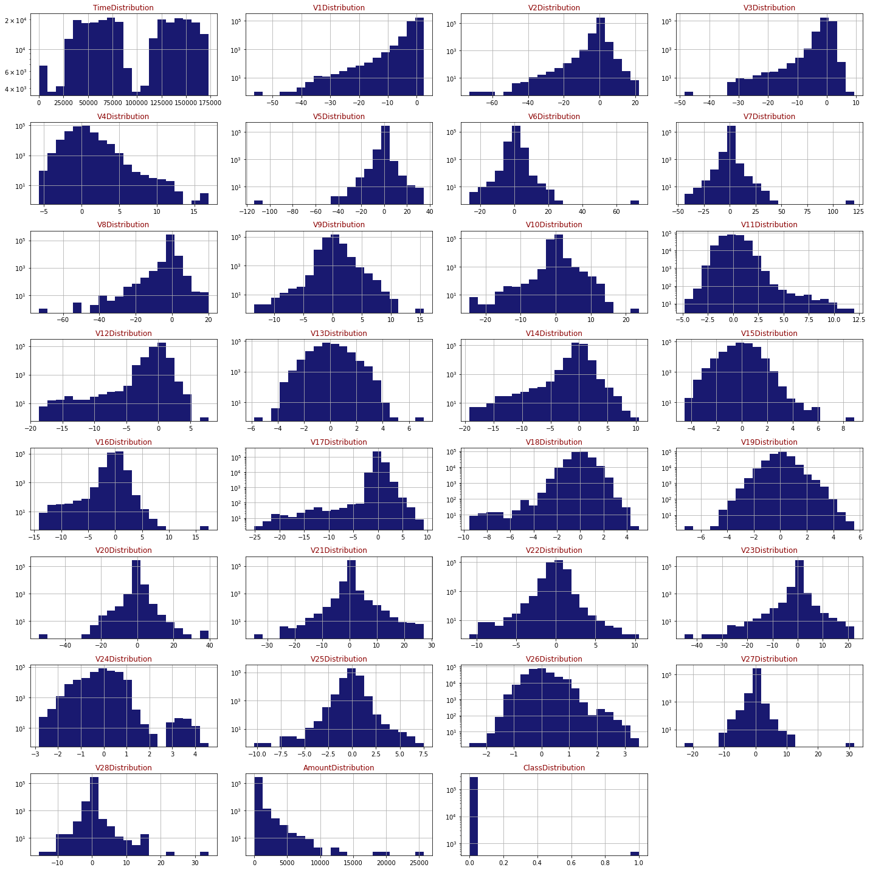

6. ### Independent and Dependent Features

X=df.drop("Class",axis=1)

y=df.Class

# Sklearn Library installing

7. pip install scikit-learn

**output**

Requirement already satisfied: scikit-learn in c:\users\ravip\anaconda3\lib\site-packages (1.0.2)

Requirement already satisfied: numpy>=1.14.6 in c:\users\ravip\anaconda3\lib\site-packages (from scikit-learn) (1.20.1)

Requirement already satisfied: scipy>=1.1.0 in c:\users\ravip\anaconda3\lib\site-packages (from scikit-learn) (1.6.2)

Requirement already satisfied: joblib>=0.11 in c:\users\ravip\anaconda3\lib\site-packages (from scikit-learn) (1.0.1)

Requirement already satisfied: threadpoolctl>=2.0.0 in c:\users\ravip\anaconda3\lib\site-packages (from scikit-learn) (2.1.0)

Note: you may need to restart the kernel to use updated packages.

8. from sklearn.linear_model import LogisticRegression

from sklearn.metrics import accuracy_score,confusion_matrix,classification_report

from sklearn.model_selection import KFold

import numpy as np

from sklearn.model_selection import GridSearchCV

import seaborn as sns

9. log_class=LogisticRegression()

grid={'C':10.0 **np.arange(-2,3),'penalty':['l1','l2']}

cv=KFold(n_splits=5,random_state=None,shuffle=False)

10. from sklearn.model_selection import train_test_split

x_train,x_test,y_train,y_test=train_test_split(X,y,train_size=0.75)

11. clf=GridSearchCV(log_class,grid,cv=cv,n_jobs=-1,scoring='f1_macro')

clf.fit(x_train,y_train)

GridSearchCV(cv=KFold(n_splits=5, random_state=None, shuffle=False),

estimator=LogisticRegression(), n_jobs=-1,

param_grid={'C': array([1.e-02, 1.e-01, 1.e+00, 1.e+01, 1.e+02]),

'penalty': ['l1', 'l2']},

scoring='f1_macro')

12. y_pred=clf.predict(x_test)

# confusion matrix

cm=confusion_matrix(y_test,y_pred)

conf_matrix=pd.DataFrame(data=cm,columns=['Predicted:0','Predicted:1'],index=['Actual:0','Actual:1'])

plt.figure(figsize=(8,5))

sns.heatmap(conf_matrix,annot=True,fmt='d',cmap="YlGnBu");

**output**

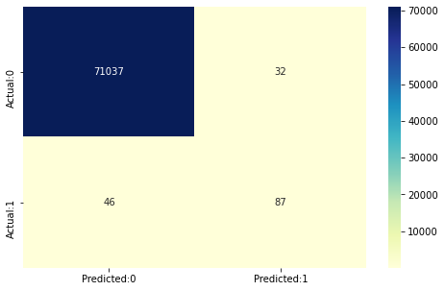

13. print(accuracy_score(y_test,y_pred))

**output**

0.9989045251537878

14. print(classification_report(y_test,y_pred))

**output**

precision recall f1-score support

0 1.00 1.00 1.00 71069

1 0.73 0.65 0.69 133

accuracy 1.00 7120

macro avg 0.87 0.83 0.84 71202

weighted avg 1.00 1.00 1.00 71202

# Random Forest classifier:

15. Random Forest classifier:

RandomForestClassifier(max_depth=10, min_samples_split=5)

16. y_pred=classifier.predict(x_test)

# confusion matrix

cm=confusion_matrix(y_test,y_pred)

conf_matrix=pd.DataFrame(data=cm,columns=['Predicted:0','Predicted:1'],index=['Actual:0','Actual:1'])

plt.figure(figsize=(8,5))

sns.heatmap(conf_matrix,annot=True,fmt='d',cmap="YlGnBu");

**output**

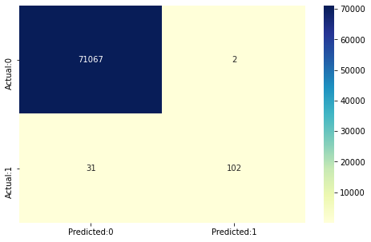

17. print(accuracy_score(y_test,y_pred))

**output**

0.9995365298727564

18. print(classification_report(y_test,y_pred))

**output**

precision recall f1-score support

0 1.00 1.00 1.00 71069

1 0.98 0.77 0.86 133

accuracy 1.00 71202

macro avg 0.99 0.88 0.93 71202

weighted avg 1.00 1.00 1.00 71202

# Importing imblearn library for performing under sampling:

19. pip install imbalanced-learn

# Performing Under sampling:NearMiss

20. from collections import Counter

Counter(y_train)

**output**

Counter({0: 213246, 1: 359})

21. from collections import Counter

from imblearn.under_sampling import NearMiss

ns=NearMiss(version=1,n_neighbors=3)

x_train_ns,y_train_ns=ns.fit_resample(x_train,y_train)

print("The number of classes before fit {}".format(Counter(y_train)))

print("The number of classes after fit {}".format(Counter(y_train_ns)))

**output**

The number of classes before fit Counter({0: 213246, 1: 359})

The number of classes after fit Counter({0: 359, 1: 359})

22. from sklearn.ensemble import RandomForestClassifier

classifier=RandomForestClassifier()

classifier.fit(x_train_ns,y_train_ns)

RandomForestClassifier()

23. y_pred=classifier.predict(x_test)

24. # confusion matrix

cm=confusion_matrix(y_test,y_pred)

conf_matrix=pd.DataFrame(data=cm,columns=['Predicted:0','Predicted:1'],index=['Actual:0','Actual:1'])

plt.figure(figsize=(8,5))

sns.heatmap(conf_matrix,annot=True,fmt='d',cmap="YlGnBu");

**output**

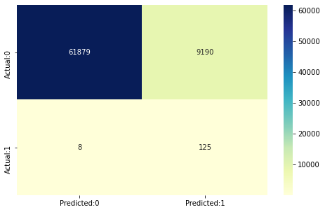

25. print(accuracy_score(y_test,y_pred))

**output**

0.8708182354428247

26. print(classification_report(y_test,y_pred))

**output**

precision recall f1-score support

0 1.00 0.87 0.93 71069

1 0.01 0.94 0.03 133

accuracy 0.87 71202

macro avg 0.51 0.91 0.48 71202

weighted avg 1.00 0.87 0.93 71202

# CatBoost:Overfit Detector

27. pip install catboost

# map categorical features

credit_catboost_ready_df=df.dropna()

features=[feat for feat in list(credit_catboost_ready_df) if feat !='Class']

print(features)

card_categories= np.where(credit_catboost_ready_df[features].dtypes !=np.float)[0]

card_categories

**output**

['Time', 'V1', 'V2', 'V3', 'V4', 'V5', 'V6', 'V7', 'V8', 'V9', 'V10', 'V11', 'V12', 'V13', 'V14', 'V15', 'V16', 'V17', 'V18', 'V19', 'V20', 'V21', 'V22', 'V23', 'V24', 'V25', 'V26', 'V27', 'V28', 'Amount']

<ipython-input-30-7f351ebd8740>:6: DeprecationWarning: `np.float` is a deprecated alias for the builtin `float`. To silence this warning, use `float` by itself. Doing this will not modify any behavior and is safe. If you specifically wanted the numpy scalar type, use `np.float64` here.

Deprecated in NumPy 1.20; for more details and guidance: <https://numpy.org/devdocs/release/1.20.0-notes.html#deprecations> card_categories= np.where(credit_catboost_ready_df[features]. dtypes !=np.float)[0array([], dtype=int64)

28. SEED=1234

from catboost import CatBoostClassifier

params={'iterations':5000,

'learning_rate':0.01,

'cat_features':card_categories,

'depth':3,

'eval_metric':'AUC',

'verbose':200,

'od_type':"Iter",

'od_wait':500,

'random_seed':SEED

}

cat_model = CatBoostClassifier(**params)

cat_model.fit(x_train,y_train,eval_set=(x_test,y_test),use_best_model=True,plot=True);

**output**

A Jupyter widget could not be displayed because the widget state could not be found. This could happen if the kernel storing the widget is no longer available, or if the widget state was not saved in the notebook. You may be able to create the widget by running the appropriate cells.

0: test: 0.7244389 best: 0.7244389 (0) total: 180ms remaining: 14m 58s

200: test: 0.9764952 best: 0.9800345 (57) total: 6.63s remaining: 2m 38s

400: test: 0.9764337 best: 0.9800345 (57) total: 11.4s remaining: 2m 10s

Stopped by overfitting detector (500 iterations wait)

bestTest = 0.9800345465

bestIteration = 57

Shrink model to first 58 iterations.

# AdaBoost Classsifier:

# Adaboost library Installing

29. pip install ada-boost

29. RANDOM_STATE = 2018

NUM_ESTIMATORS = 100

target = 'Class'

**output**

predictors = ['Time', 'V1', 'V2', 'V3', 'V4', 'V5', 'V6', 'V7', 'V8', 'V9', 'V10', 'V11', 'V12', 'V13', 'V14', 'V15', 'V16', 'V17', 'V18', 'V19', 'V20', 'V21', 'V22', 'V23', 'V24', 'V25', 'V26', 'V27', 'V28', 'Amount']

31. from sklearn.ensemble import AdaBoostClassifier

clf = AdaBoostClassifier(random_state=RANDOM_STATE,

algorithm='SAMME.R',

learning_rate=0.8,

n_estimators=NUM_ESTIMATORS)

30. clf.fit(df[predictors],df['Class'].values)

AdaBoostClassifier(learning_rate=0.8, n_estimators=100, random_state=2018)

31. y_pred = clf.predict(df[predictors])

cm=pd.crosstab(df[target].values,y_pred,rownames=['Actual'],colnames=['Predicted'])

fig, (ax1)=plt.subplots(ncols=1,figsize=(5,5))

sns.heatmap(cm,

xticklabels=['Not Fraud','Fraud'],

yticklabels=['Not Fraud','Fraud'],

annot=True,ax=ax1,

linewidths=2,linecolor="Darkblue",cmap="Blues")

plt.title('Confusion Matrix',fontsize=14)

plt.show()

**output**

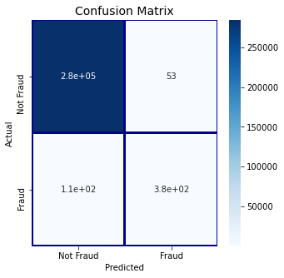

# Installing matplotlib for plotting graph

32. pip install matplotlib

33. pip install seaborn

34. # confusion matrix

import seaborn as sns

import matplotlib.pyplot as plt

y_pred = cat_model.predict(x_test)

35. # confusion matrix

cm=confusion_matrix(y_test,y_pred)

conf_matrix=pd.DataFrame(data=cm,columns=['Predicted:0','Predicted:1'],index=['Actual:0','Actual:1'])

plt.figure(figsize=(8,5))

sns.heatmap(conf_matrix,annot=True,fmt='d',cmap="YlGnBu");

**output**

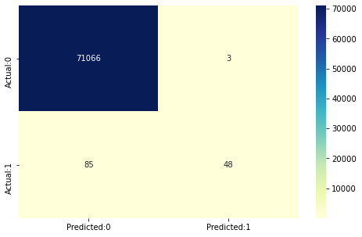

# SMOTE Analysis

36. pip install imblearn

37. from imblearn.combine import SMOTETomek

38. os=SMOTETomek(random_state=42)

x_train_ns,y_train_ns=os.fit_resample(x_train,y_train)

print("The number of classes before fit {}".format(Counter(y_train)))

print("The number of classes after fit {}".format(Counter(y_train_ns)))

**output**

The number of classes before fit Counter({0: 213246, 1: 359})

The number of classes after fit Counter({0: 212728, 1: 212728})

39. from sklearn.ensemble import RandomForestClassifier

classifier=RandomForestClassifier()

classifier.fit(x_train_ns,y_train_ns)

**output**

RandomForestClassifier()

40 . y_pred=classifier.predict(x_test)

41. # confusion Matrix

cm=confusion_matrix(y_test,y_pred)

conf_matrix=pd.DataFrame(data=cm,columns=['Predicted:0','Predicted:1'],index=['Actual:0','Actual:1'])

plt.figure(figsize = (8,5))

sns.heatmap(conf_matrix,annot=True,fmt='d',cmap="YlGnBu");

**output**

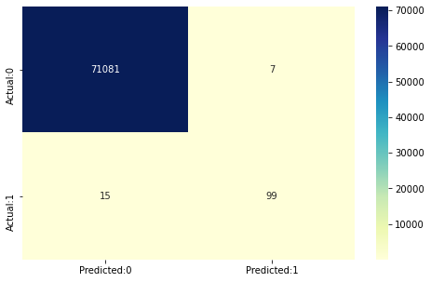

42. print(accuracy_score(y_test,y_pred))

**Output**

0.999691019915171

43. print(classification_report(y_test,y_pred))

**Output**

precision recall f1-score support

0 1.00 1.00 1.00 71088

1 0.93 0.87 0.90 114

accuracy 1.00 71202

macro avg 0.97 0.93 0.95 71202

weighted avg 1.00 1.00 1.00 71202

43. df_temp=df.drop(columns=['Time','Amount','Class'],axis=1)

# create dist plots

fig, ax = plt.subplots(ncols=4, nrows=7, figsize=(20,50))

index = 0

ax = ax.flatten()

for col in df_temp.columns:

sns.distplot(df_temp[col], ax=ax[index])

index +=1

plt.tight_layout(pad=0.5,w_pad=0.5,h_pad=5)

**output**

